**Course Project – Final**

Shaun Pritchard

Rasmussen College

QMB3200

Kimberly Powell

August 08,2020

**Course Project – Final**

Below are the requirements for the final course project including all course project SAS Scripts 2-5 completely re modified to meet the standards guidelines. Sales projection output and test data output for all Scripts is included with the formatting that meet the standards guidelines. Please see below. No test validation due to instructors request.

**Code Module 2:**

[Module 02 Course Project - Reading Datasets](https://learning.rasmussen.edu/webapps/assignment/uploadAssignment?content_id=_6268939_1&course_id=_69490_1&group_id=&mode=view) shows reading datasets in with the following files.

* train.csv
* test.csv
* stores.xlsx
* features.csv

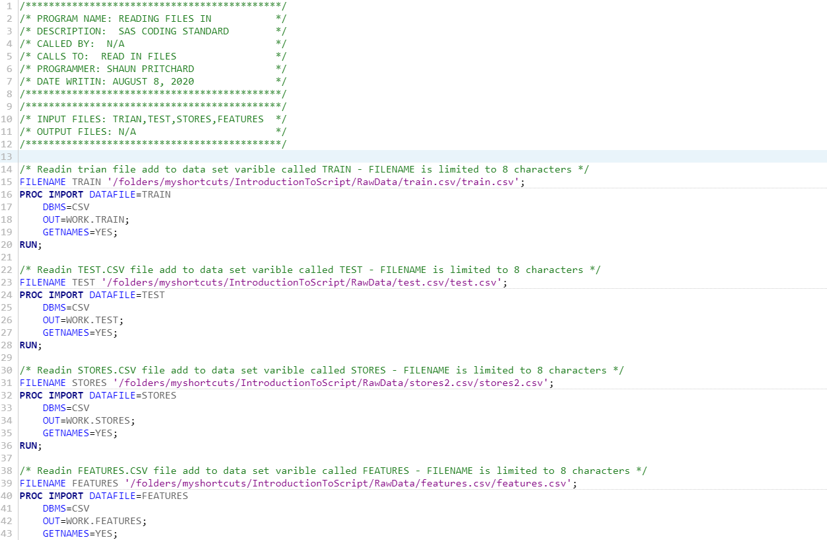

**Code Output Module 2:**

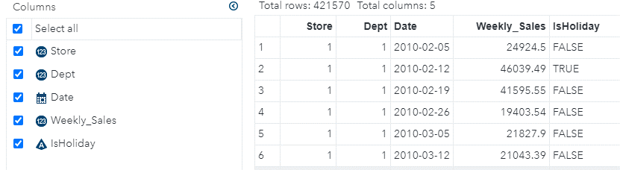

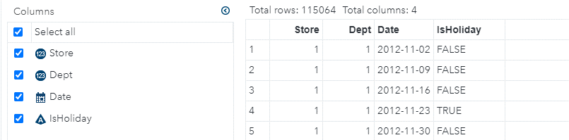

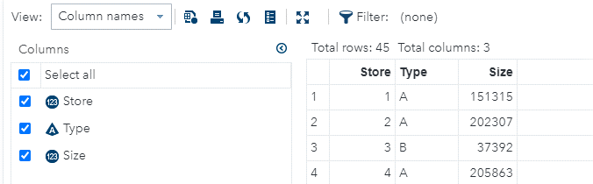

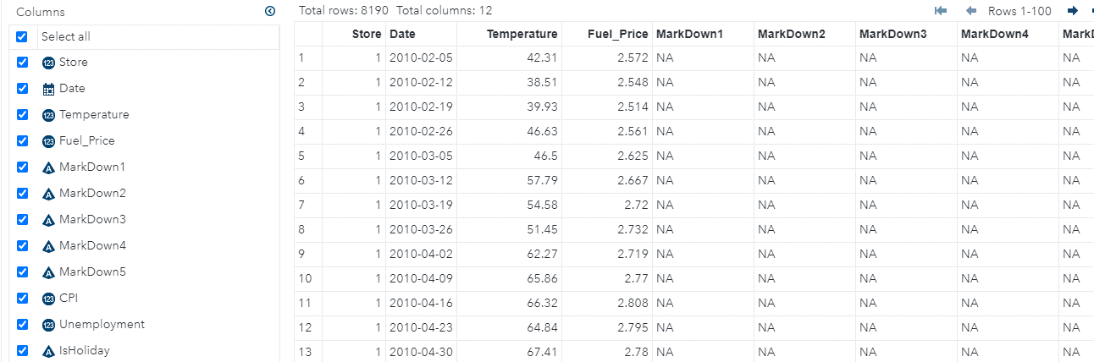

**Code Module 3:**

Module 03 Course Project - Weekly Sales calculate descriptive statistics that represents weekly sales for a certain department in a given store in a given week.

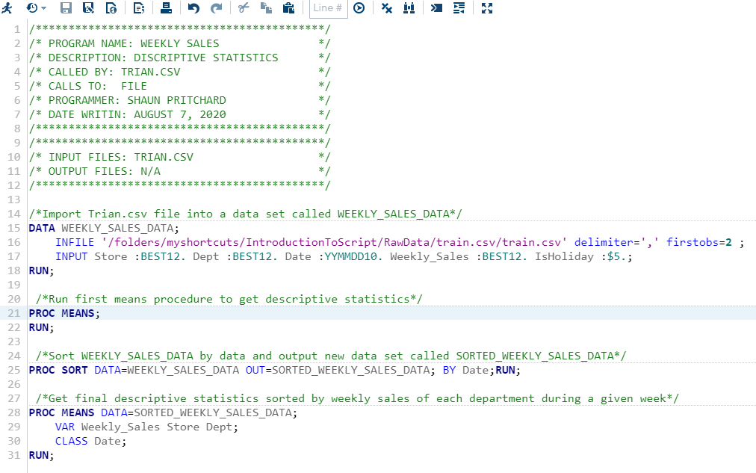

**Code Output Module 3:**

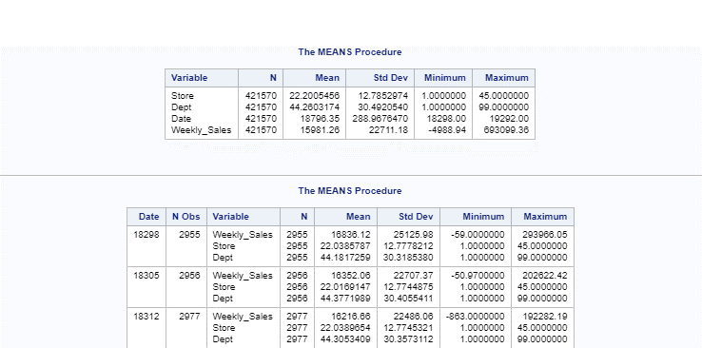

**Code Module 4:**

 Module 04 Course Project - Outputs Using the data from the Train.csv file

* Step 1: Include PROC UNIVARIATE in your SAS script and calculates mean sales over the holiday per store/department for each month.
* Step 2: Produce the standard deviation over the holiday per store/department for each month.
* Step 3: Produce the min and max range over the holiday per store/department for each month.
* Step 4: Use ODS interface and generate all the output in graphical format.

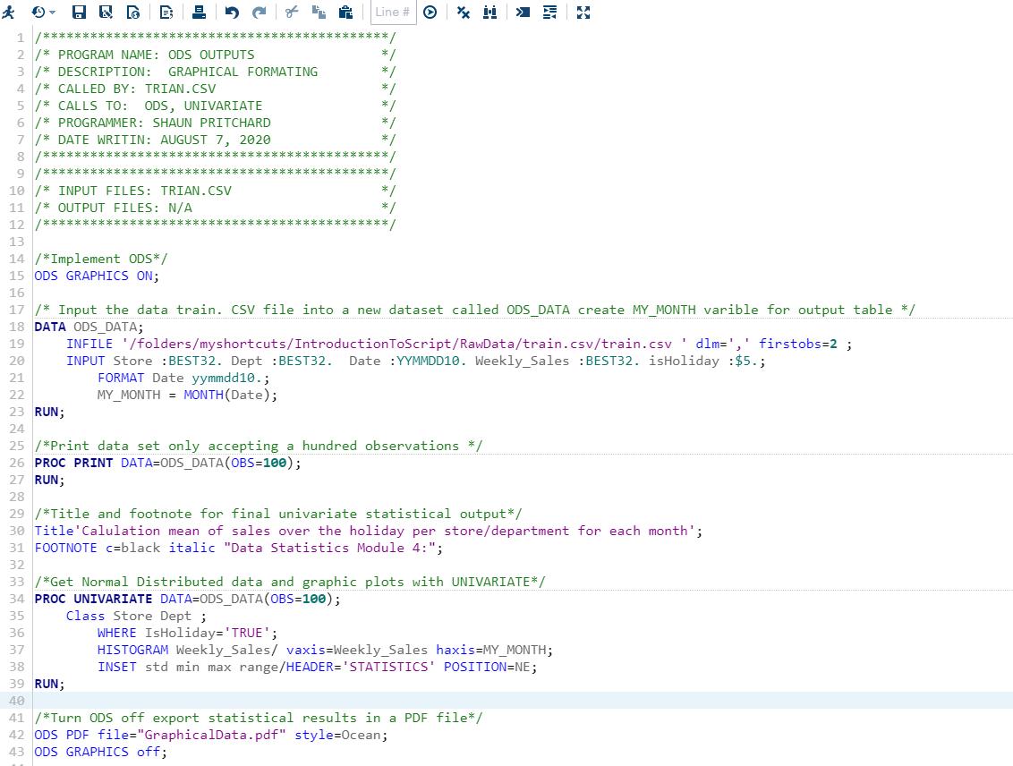

**Code Output Module 4:**

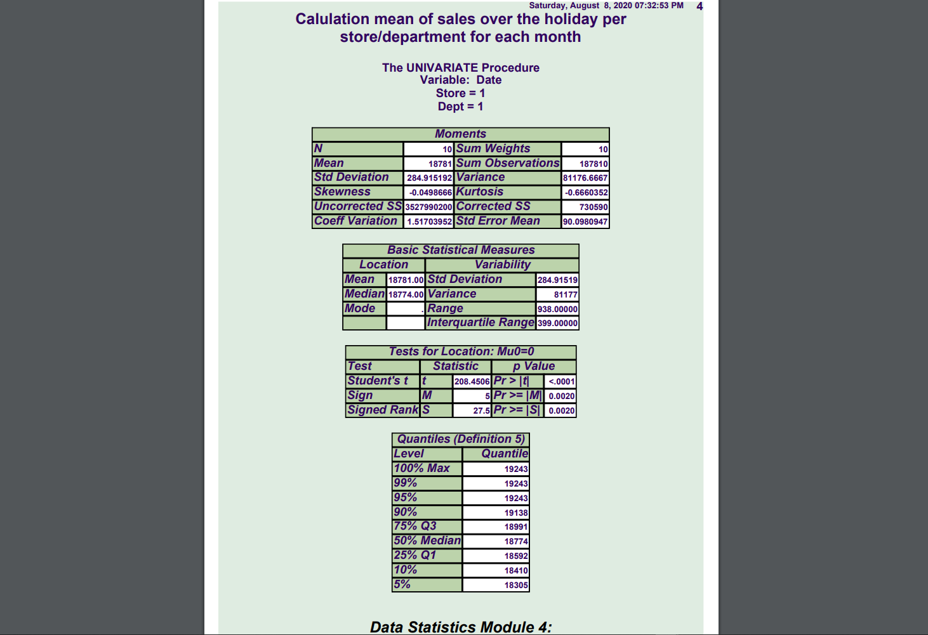

**Code Module 5:**

Team Lead,

I am writing you today to discuss some of the issues that I found in the programming script based on proper SAS coding guidelines.

First off there was no notation or comment describing the procedures. Also, the spacing tabulation of the code was not formatted correctly. The datasets instantiation did not meet the naming conventions. The labels of the initial dataset X were changed to CODE_DATA_X giving it more description. The next issue in the script was on line 32 to drop variables I, J, and TEMPVAR. These variables being uninitialized. If they were initialized, then the iterations in the conditional logic would not be able to compute therefore rendering the first loop statement useless.

The end script for the first Loop iteration was missing a semicolon. The next procedure I had to change the data variables to the new instantiation of the data set CODE_DATA_X. I went ahead an uninitialized the whole procedure because the data was being calculated buy a conditional variable called **YEARs**. I did not know if that “**s**” being lowercase at the end of the variable was a typo. If not, there would have been no variable or condition in the logic to supplement the procedure being that the final loop calls for YEAR variable. Therefore, on the next procedure I replace the data set variable Y with CODE_DATA_X. This is because there was no dataset initialized called Y.

Following those procedure statements, the loop iterations held three conditional loops that would take I, J and K variables looping 10 sets of 100 Loops within 50 loops. Also, there was an uninitiated variable called “**statements**” that I removed. Furthermore, on the last conditional statement where the variable YEAR was actually implemented. There was not enough information to know if the variable naming standards such as GT stood for something in particular. Also, the categorical variables for gender EQ?

Upon this I added conditional author comment block section and description to the script document. Outlining the procedures, changes, and other valuable data as it was given including added system functions to time the start and end of the procedure in memory.

I then added proper formatting to the code as for the standard guidelines of SAS. I added proper indentation on all loops and procedures. I added descriptive comments for each section of code with proper line spacing, renamed variables to be descriptive. I made the program appearance and readability substantial while reflecting the actual information being presented while avoiding implicit coding. Please see my code below, thank you.

**Code:**

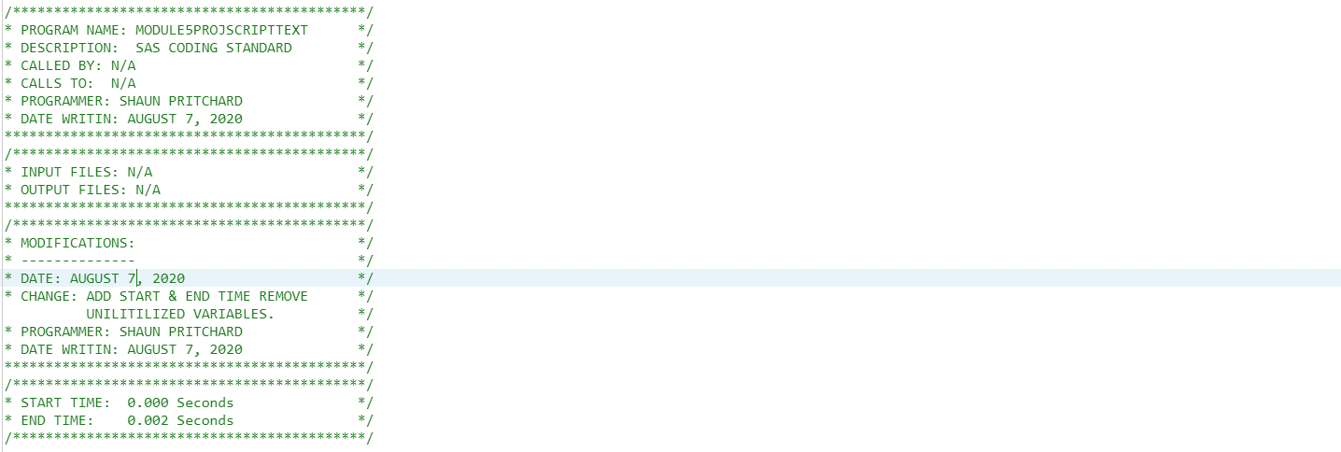

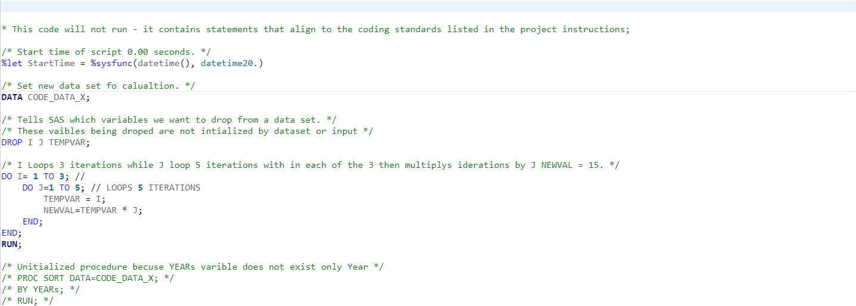

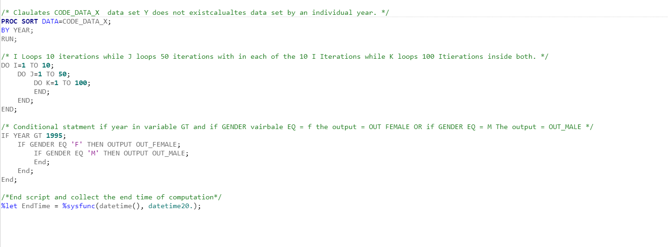

**Code Output Module 5:**

No output available.